‘Go Green on Lamma Island’ Programme Series
(1): Renewable Energy

Field Trip Activities on Lamma Island

Name: ________________( ) | S. _______ | Date: _______________

Stop 1 Viewing at Lamma Power Station
- Write the letters in the space provided to show the components of power station in Figure 1.
Components of Power Station:
- Coal-fired Generating Units | - Gas-fired Combined-cycle Generating Units | - Oil-fired Generating Units
- Coal Yard | - Ash Lagoon | - Transport jetty
Figure 1 Components of Power Station
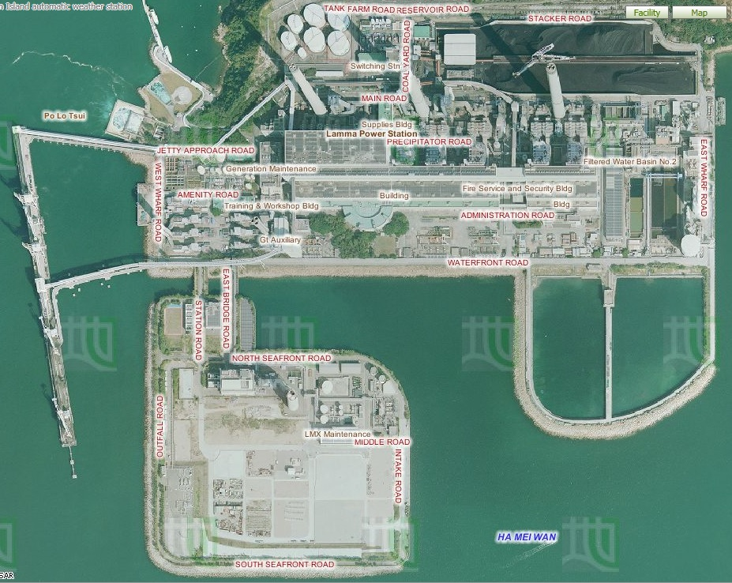
4.
6.
2.
5.
3.
1.
Lamma Power Station Extension

Aerial Photos from Lands Department
- Describe and explain the locational advantages of the power station.
Locational characteristics | Reasons
Is it located near the coast?

Is it sheltered by hills?

Is it near the residential areas?

- Table 2 shows the capacity of the Lamma Power Station.
Table 2 Capacity of the Lamma Power Station in 2013

 | Number of units | Capacity of each unit (MW) | Total capacity (MW)
Coal-fired Generating units | 3 | 250 | 750
 | 5 | 350 | 1750
Oil-fired Generating Units | 4 | 125 | 500
 | 1 | 55 | 55
Gas-fired Combined-cycle Generating Units | 1 | 335 | 335
 | 1 | 345 | 345
Solar Power System |  |  | 1
Lamma Winds |  |  | 0.8
Total |  |  | 3736.8
Source: Hong Kong Electric
https://www.hkelectric.com/en/MediaResources/Documents/LPS_2014.pdf
- What energy source (Hint: a type of fuels) is mainly used in the electricity generation? What do they include? Are they renewable?

- (b) Among these fuels, which one is mainly used to generate electricity in
- the power station? Which one has been increasingly used to generate
- electricity recently? (Hint: Think about what kind of generating unit
- has been built in the newly-reclaimed area)
- (b) Among these fuels, which one is mainly used to generate electricity in
- the power station? Which one has been increasingly used to generate
- electricity recently? (Hint: Think about what kind of generating unit
- has been built in the newly-reclaimed area)
- Among these fuels, which one is mainly used to generate electricity in
- the power station? Which one has been increasingly used to generate
- electricity recently? (Hint: Think about what kind of generating unit
- has been built in the newly-reclaimed area)
(b) Among the fuels mentioned in (a), which one is mainly used to generate electricity in the power station?
(c) What kind of fuels has been increasingly used to generate electricity recently? (Hint: Think about what kind of generating unit has been built in the newly-reclaimed area?)

4. Observe the power station. Does the power station cause air pollution? If yes, what kinds of air pollutants are released?

5. Figure 3 shows the amount of air pollutants emitted from coal-fired and gas-fired generating units respectively when the total electricity generation in the year 2012 would increase by 2.57 times compared with that in 1990.
Figure 3 Amount of Air Pollutants Emitted from the Coal-fired and Gas-fired Units
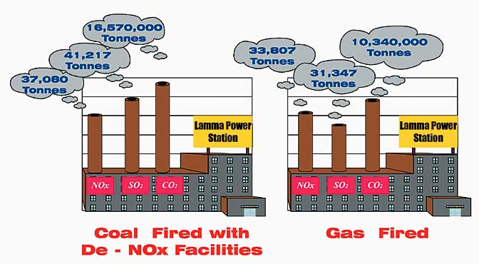

Source: Environmental Protection Department, HKSAR Government
http://www.epd.gov.hk/eia/operation/english/chapter05_4.html
- Why does the power station cause climate change?

- More generating units will be built to generate more electricity in future. Explain why.

- Which kind of fossil fuels, coal or natural gas, should be more widely-used in the new generating units? Explain why.

- Do you think that using a mixture of different types of fossil fuels only can help to minimize climate change in future? Why?

Stop 2 Lamma Winds
Is the use of renewable energy a way out in Hong Kong?

- What types of renewable energy are used at this site?

- Why is it suitable to set up the wind turbine at this site? Give five reasons.

Is it easy to find similar site to build wind farm in Hong Kong? Why?

- Collect the data at the tower base of the wind turbine and complete the following table.
Date & time | 12 Jan 2017 at  10:34 p.m.
Present wind speed | 5.9 m/s | m/s
Present power output | 198.1 kW | kW
Cumulative electricity generated | 9442719 kWh | MWh
Amount of carbon dioxide (CO₂) saved | 7868932 kg | tonnes
Remarks: The units of cumulative electricity generated and amount of carbon dioxide saved shown on HK Electric’s website are different from those shown at the tower base of the wind turbine.

What is the relationship between wind speed and power output?

- In 2013, the electricity consumption was 44.21 billion kWh in Hong Kong. Do you think that this wind turbine generates a lot of electricity? Give evidence to support your answer.

Explain why this wind turbine cannot be designed to produce a lot of electricity.

- By observation, list the environmental problem(s) caused by the wind turbine.

- Should different types of renewable energy, particularly solar energy and wind energy, be further developed in Hong Kong?
Each group will be assigned one of the following roles. Collect the information from the exhibition panels for discussion.
Role | Tasks
Government | Discuss why different types of renewable energy should be further developed in relation to existing environmental problems
Spokesman from a power company | Discuss whether the development of different types of renewable energy is cost-effective
Environmentalist | Discuss the negative impact of the development of different types of renewable energy on the environment
Urban planner | Discuss the problems in the selection of suitable sites for the development of different types of renewable energy
Spokesman from Department of Energy | Discuss whether different types of renewable energy can give abundant and reliable energy supply in Hong Kong and their energy efficiency
Your role:
Your opinion:

- Do you agree that the renewable energy should be further developed in Hong Kong as a sustainable measure against global warming? Why?
Strongly disagree Disagree Agree Strongly agree
Give at least three reasons:

- The use of technical measures, like fuel mix and renewable energy, seems not to be the most sustainable way to combat climate change caused by power station. Then what else can we do to solve this problem?

